Experiment No 4
- Title: Use function types, scope, and closures; apply try-catch build a palindrome checker.

2. Software/Tools Required:
- Visual Studio Code (VS Code)
- Google Chrome
- HTML5
- JavaScript
3. Theory:
Function Types: JavaScript supports multiple ways to define functions:
- Function Declarations : Standard named functions.
- Arrow Functions : Concise syntax for function expressions.
Scope: Determines the accessibility of variables:
- Global Scope: Accessible everywhere.
- Local : Variables declared with let inside a block or function are restricted to that block.
Closure: A function’s ability to "remember" and access variables from its outer lexical scope, even after the outer function has finished executing.
Exception Handling : Used to handle runtime errors gracefully without stopping program execution.

4. Output:
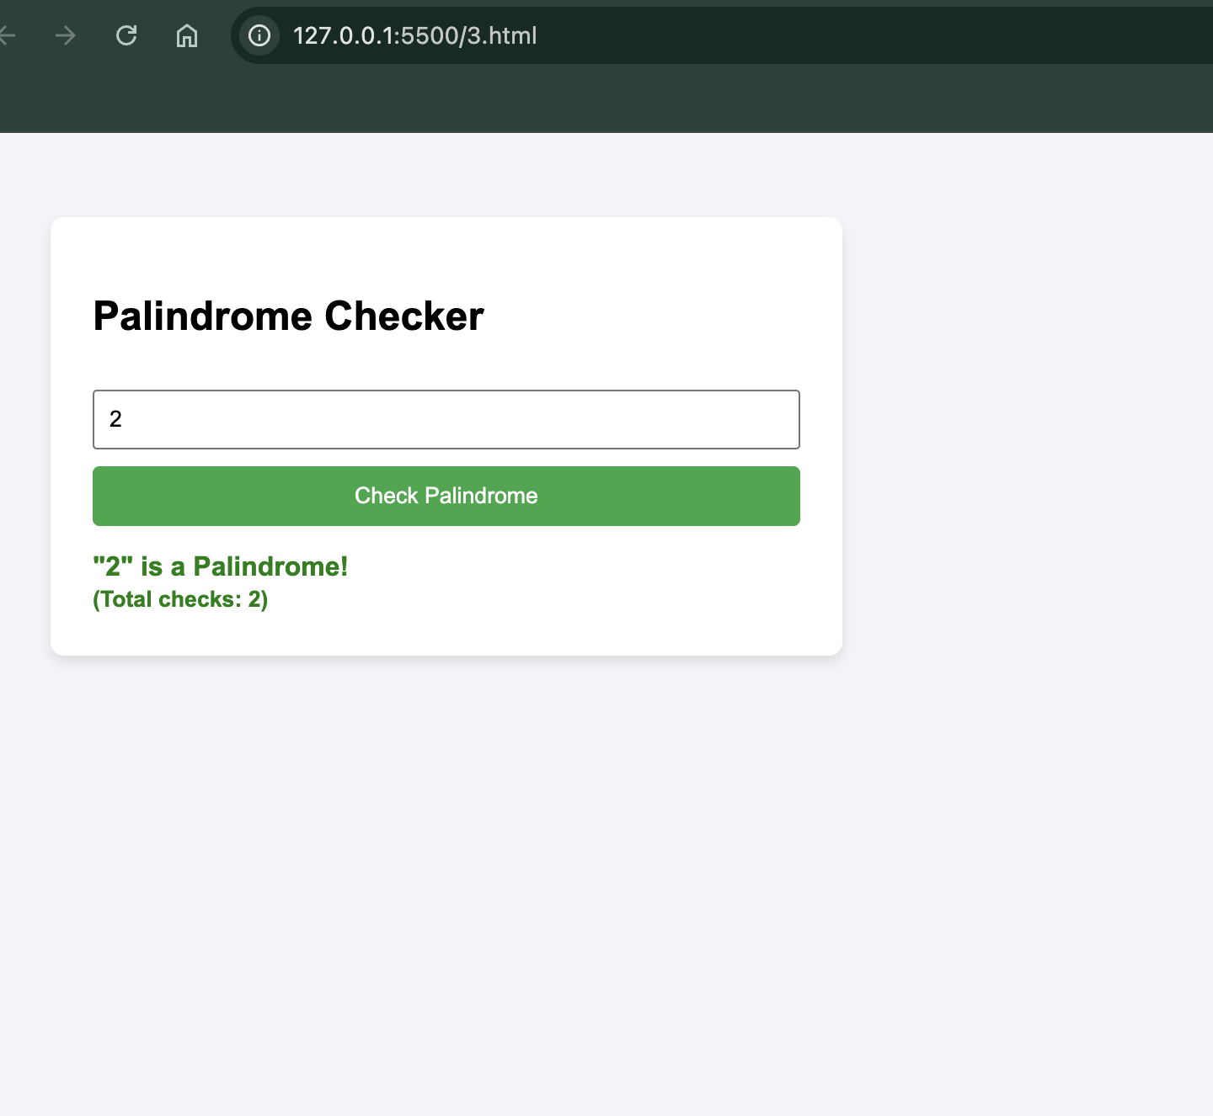
Vedant 1245

5. Result/Conclusion:
The application was successfully created. It demonstrates function declarations, arrow functions, lexical scope, closures and error handling using try-catch within a dynamic Palindrome Checker application.

